Experiment No: 1
Experiment Name: Find the Bigger Number
Task Name
Write a Java program to determine the bigger number between two numbers.
Objective
• To learn how to take input from the user
• To understand conditional statements in Java
• To compare two numbers
Problem Analysis
In this program, the user enters two numbers and the program determines which number is bigger using an if-else condition.
Input: Two numbers from the user
Process: Compare the numbers using if-else condition
Output: Display the bigger number
Algorithm
- Start
- Import Scanner class
- Take two numbers as input
- Compare numbers using if condition
- Display the bigger number
- End
Source Code:
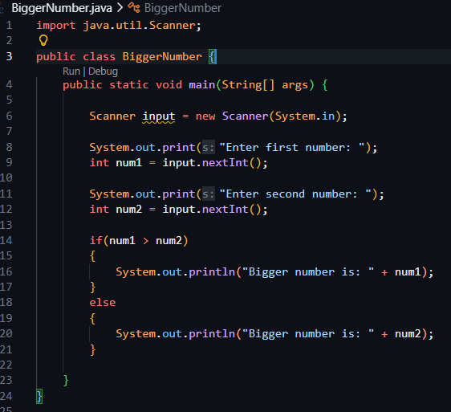

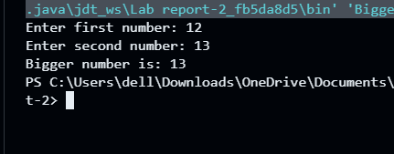
Output:

Discussion
In this experiment, I learned how to take input using Scanner and compare two numbers using an if-else condition.

Experiment No: 2
Experiment Name
Simple Calculator Using Switch Statement
Task Name
Write a Java program that asks the user for two numbers and an operator (+, -, *, /) and performs the selected operation.
Objective
• To learn how to use switch statements in Java
• To perform arithmetic operations
• To understand user input handling
Problem Analysis
In this program, the user enters two numbers and an operator. The program checks the operator and performs the corresponding arithmetic operation using a switch statement.
Input: Two numbers and an operator from the user
Process: Perform arithmetic operation using switch statement
Output: Display the calculated result
Algorithm
- Start
- Import Scanner class
- Take first number as input
- Take second number as input
- Take operator input
- Use switch statement to perform calculation
- Display the result
- End
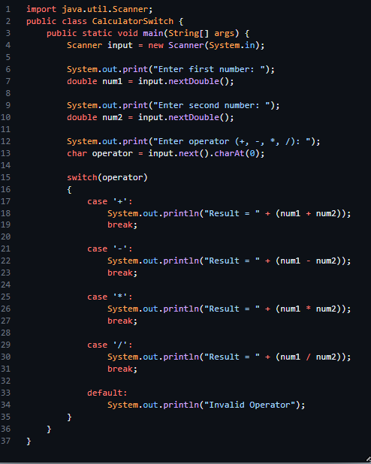
Source Code:

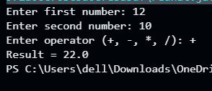
Output:

Discussion
In this experiment, I learned how to use switch statements in Java to perform different arithmetic operations based on user input. The program takes two numbers and an operator from the user and calculates the result accordingly.

